

P.O. Box BE 277. Ganges Road,

Belvedere, Harare. ZIMBABWE

Office: W102. First Floor. Admin-Block

Tel: 263-4-741422-37 Ext: 2331

**SIST UNDERGRADUATE UNIT**

**COMPUTER SCIENCE**

**BTech in Computer Science**

**Healthcare Assistant for Hypertension**

Project Documentation

**H210403Q – Nlisi Malaba**

Supervisor: Mrs. Chiwanza

**2024- 2025**

**CERTIFICATE**

**THIS IS TO CERTIFY THAT RESEARCH WORK EMBODIED IN THIS THESIS ENTITLED “HEALTHCARE ASSISTANT FOR HYPERTENSION” DONE BY NLISI MALABA (REGISTRATION NO: H210403Q) STUDYING AT HARARE INSTITUTE OF TECHNOLOGY FOR PARTIAL FULFILMENT OF BACHELOR OF TECHNOLOGY DEGREE IN COMPUTER SCIENCE TO BE AWARDED BY THE HARARE INSTITUTE OF TECHNOLOGY.THIS RESEARCH WORK HAS BEEN CARRIED OUT UNDER MY GUIDANCE AND SUPERVISION AND IT IS UP TO MY SATISFACTION.**

Student’s signature …………………… Date ..…./…..…/……….

(Nlisi Malaba)

Department of Computer Science

Harare Institute of Technology

Supervisor’s signature ………………….. Date ……. /……..……/……

(Mrs. M. Gondo)

Department of Computer Science

Harare Institute of Technology

P O Box BE 277

Belvedere

Harare, Zimbabwe

**PAPER PUBLICATION CERTIFICATE**

**THIS IS TO CERTIFY THAT RESEARCH WORK EMBODIED IN THIS THESIS ENTITLED “HEALTHCARE ASSISTANT FOR HYPERTENSION” WAS CARRIED OUT BY STUDYING AT HARARE INSTITUTE OF TECHNOLOGY FOR PARTIAL FULFILMENT OF BACHELOR OF TECHNOLOGY DEGREE IN COMPUTER SCIENCE TO BE AWARDED TO NLISI MALABA (REGISTRATION NO: H210403Q) HARARE INSTITUTE OF TECHNOLOGY HAS PUBLISHED ARTICLE ENTITLED“WEB BASED IDE TAILORED FOR HIT SIST PROGRAMMING COURSES” FOR PUBLICATION BY THE HARARE INSTITUTE OF TECHNOLOGY SCHOOL OF INFORMATION SCIENCES AND TECHNOLOGY JOURNAL.**

Date: ……………………….

Place: ………………………

**Mrs. Chiwanza**

Supervisor & Lecturer from CS Department, Harare Institute of Technology, Harare, Zimbabwe

Signature ……………………….

Stamp

**Name & Signature of Dean**

**………………………………………………………………………………………**

**THESIS APPROVAL CERTIFICATE**

This is to certify that research work embodied in this thesis entitled “**HEALTHCARE ASSISTANT FOR HYPERTENSION**” was carried out by studying at Harare Institute of Technology for partial fulfilment of bachelor of technology degree in Computer Science to be awarded by Nlisi Malaba (registration no: H210403Q) Harare Institute of Technology has published article entitled “**HEALTHCARE ASSISTANT FOR HYPERTENSION**” for publication by the Harare institute of technology school of information sciences and technology journal.

**Date:**

**Place:**

**Examiners Signature and Name:**

**(………………………………………………………………)**

**(………………………………………………………………)**

**STATEMENT OF ORIGINALITY**

We hereby certify that we are the sole authors of this thesis and that neither any part of this thesis nor the whole of the thesis has been submitted for a degree to any other university or institution.

We certify that, to the best of our knowledge, the current thesis does not infringe upon anyone’s copyright nor violate any proprietary rights and that any ideas, techniques, quotations or any other material from the work of other people included in our thesis, published or otherwise, are fully acknowledged in accordance with the standard referencing practices. Furthermore, to the extent that we have included copyrighted material that surpasses the boundary of fair dealing. We certify that we have obtained a written permission from the copyright owner(s)to include such material(s)in the current thesis and have included copies of such copyright clearances to our appendix

We declare that this is a true copy of thesis, including any final revisions, as approved by thesis review committee.

We have checked write up of the present thesis using anti-plagiarism database and it is in allowable limit. Even though later on in case of any complaint pertaining of plagiarism, we are sole responsible for the same and we understand that as per hit norms, the institute can even revoke bachelor of technology degree conferred to the student submitting this thesis.

Date:

Place:

…………………………………………………

Mr. N. Malaba (H210403Q) Harare Institute Of Technology, Harare, Zimbabwe

…………………………………………………

Ms Chiwanza Harare Institute Of Technology, Harare, Zimbabwe

**ACKNOWLEDGEMENTS**

I would like to express our sincere gratitude to all those who have contributed to the successful completion of this project.

First and foremost, I am immensely thankful to God for providing everything necessary to finish both this project and the program it was intended for. I never experienced any shortage or deficiency, as He took care of all obstacles that could have hindered my progress and supported me even during my toughest moments throughout this study.

I would like to thank my project supervisor, Mrs Gondo, for providing me with invaluable guidance and support throughout the entire project. Your expertise and insights have been instrumental in shaping my ideas and ensuring that I stay on track.

I would also like to extend my appreciation to the staff and faculty members of Harare Institute Of Technology who provided me with access to resources, facilities, and equipment that were essential for the completion of this project.

Special mentions go out to my colleagues Nigel Mashayamombe, Sydney Muzadzi and Ruramai Botso for their exceptional contributions in various aspects of this project. Your dedication, hard work, and creativity have been truly inspiring.

Thank you all once again for your invaluable contributions towards this project.

**DEDICATION**

I would like to dedicate this to my family, my mother, father and siblings who have provided me with emotional support and encouragement throughout this journey. Your unwavering belief in me has been a constant source of motivation.

**ABSTRACT**

**TABLE OF CONTENTS**

**LIST OF APPENDICIES**

**LIST OF FIGURES**

**LIST OF TABLES**

**CHAPTER 1: Introduction to the study**

* 1. **Introduction**

Hypertension, a non-communicable disease (NCD) is one of the leading causes of many deaths, especially in low- and middle-income countries. It is a silent killer and has been considered a public health crisis by many countries, including Zimbabwe. Most people in Zimbabwe generally have unhealthy dietary habits and sedentary lifestyles, which contribute a lot to increasing hypertension prevalence, which often goes undiagnosed until severe consequences such as stroke or heart disease.

In Zimbabwe, such a disease is very difficult to detect early as we lack resources, leading to most cases being complications that could have been avoided, hence also further burdening our already strained health system. Therefore, this project seeks to develop an AI-powered healthcare assistant that will help predict hypertension based on user data and also help with management of hypertension.

The system will use machine learning to analyse patient information or data, such as lifestyle and medical history, and come up with a prediction if the user is likely to have hypertension in the future. This will equip doctors with a tool that will help detect hypertension early and possibly reduce complications such as stroke or heart disease.  
  
This project is in line with Zimbabwe’s National Health Strategy (NHS) 2016-2020, which emphasizes the use of technology to deal with NCDs and other health issues. Moreover, it offers a model that could be scaled up to other countries in Southern Africa.

* 1. **Background to the problem/study**

Hypertension, a known silent killer disease is one of the biggest worries around the world including Zimbabwe. The main goal of this research and project is to discover how non-communicable diseases (NCD) have increased in Zimbabwe, mainly focusing on hypertension in the last few decades. According to the World Health Organization (WHO), over 17 million people are estimated to die of NCDs such as hypertension globally. This has mainly been due to socioeconomic development such as changes in diet, reduced physical activity, and high stress levels.

However, the high frequency of hypertension in Zimbabwe is also because most citizens have no access to adequate healthcare. Many people also cannot afford health checkups that often and usually seek medical care after they have developed severe symptoms. In the case of NCDs (hypertension) most of the time the damage will be done. Hypertension needs to be diagnosed and controlled at early stages before it worsens as this usually leads to cases like heart disease, stroke, and even kidney failure. This also creates more burden to our already struggling healthcare system in Zimbabwe.

The government has however made efforts to educate citizens and offer free blood pressure check-ups but that has not been effective enough to reduce the increasing cases of hypertension among the population. Therefore, this project aims to design an AI-powered healthcare assistant capable of predicting if a patient is likely to have hypertension in the future. The system will make use of machine learning to predict and give insights to users.

Although hypertension is a preventable and manageable disease, it is almost always detected late in Zimbabwe, hence the research is on the desire to have a new model of handling hypertension. This is an opportunity to utilize AI in early detection to improve the quality of life for patients and reduce the workload of doctors.

## Research Question

It also asks, ‘‘how will an AI-Healthcare assistant that employs Natural Language Processing (NLP) can design an Early Hypertension Screening and Reminders solution to Screen and Remind the Zimbabwean population about hypertension and what impact can this have on the health outcomes of the populace.’’

The answer to this question will respond to what we believe is the need to establish cost-effective means of taking health care to the people in Zimbabwe with especial consideration to hypertension. The healthcare market lacks tools that could be filled up by this research in order to introduce into practice the uses of artificial intelligence for hypertension treatment in the country.

* 1. **Problem Statement**

Early detection and consistent management are critical to reducing the impact of hypertension. Patients lack access to predictive tools and regular monitoring systems that could help them understand and manage their condition effectively. Also, poor medication adherence for patients with hypertension already remains an issue as some patients often forget to take medication leading to serious consequences. These challenges highlight the need for an inclusive solution that leverages modern technology

* 1. **Aims**
* To develop an AI-powered healthcare assistant that facilitates early detection and management of hypertension.
* To provide a comprehensive platform for patients, doctors, pharmacies, and administrators to enhance healthcare delivery and accessibility.
* To integrate AI technologies for predictive healthcare analytics and personalized care.
* To streamline communication and interaction among healthcare stakeholders through a unified application.
  1. **Objectives**
* Develop an AI model to predict hypertension risk using patient data (e.g., age, weight, blood pressure history, lifestyle factors).
* Enable patients to track blood pressure and pulse rate via app inputs with AI-driven anomaly detection.
* Implement a reminder system for medication schedules, using background services or tasks to trigger alerts even when the app is closed.
  1. **Significance of the Project**

The project is important because it will help to explain the rising public health problem of hypertension in Zimbabwe. The development of an AI-powered healthcare assistant for early hypertension prediction benefits:

1. HealthcareSector: Due to issues such as lack of healthcare resources, the Zimbabwean healthcare system will benefit greatly from the AI technology tools that can help in predicting, controlling and managing hypertension. This project will enable the health care sector to make right decisions by the right time to help reduce complications such as stroke and heart diseases.

2. PatientsandtheCommunity: Hypertension management is dependent on early detection to avoid the more severe outcomes associated with the condition. This helps patients get the help early and prevent more serious complications in the future.

3. Government and Policy Makers: The research is relevant to Zimbabwe’s National Health Strategy that aims on how best to use technology in addressing NCDs.

* 1. **Hypothesis**
  2. **Methodology**

The following sub-topics are the framework that will be used in the execution of the research work to fill the gap created by lack of an AI-based predictive tool for hypertension in Zimbabwe. The choice of methodology has been influenced by the literature on health technology adoption and AI in health for accuracy, reliability and the utility of the study findings in the Zimbabwean health sector.

## 1. Research Design

The study will use both quantitative and qualitative research processes, in order to increase the credibility of the findings. This approach will enable understanding the nature of hypertension diagnosis and the prospects for using AI in low-resource setting comprehensively. The quantitative component would concern the patient information collected as well as analyzed for feeding the AI model and the qualitative component would concern the user us experiences as well as feedbacks concerning the use of the application from the patients and the healthcare professionals.

The research will include the design of an mHealth application that is used in hypertension screening and evaluation of its performance using a number of real patient data. This design will give a balance between the methodical performance of the AI model, and the practicability of such a model in Zimbabwe’s environment.

## 2. Population and Sampling

The target participants in the study will be persons with hypertension or other risk factors, healthcare givers, health technicians such as doctors, nurses, individuals using technology and living in both rural and urban communities in Zimbabwe. More specifically, 300 patient records, of the healthcare centers in Zimbabwe, will be utilized to both train as well as to evaluate the AI model. To protect the privacy of data that will be retained, these records shall be de-identified. Furthermore, 30 users, patient and healthcare consumers, will be selected for testing the application.

Through purposive sampling method, the participants to be sampled will include patients who are at risk of hypertension in relation to the research questions, healthcare providers who have worked with patients at Rachuonyora health facility and are conversant with the health challenges faced in the area including Rachuonyora sub-county, and users of technology in both rural and urban areas. This will help in making sure that the study will have sample respondents from different parts in order that the study could have broad conclusions.

## 3. Data Collection Procedures

Data collection will occur in two stages:

**Stage 1: Secondary Data Collection**

During this phase, actual individual details of patients together with their family history, life style, diet etc. will be obtained from local hospitals/clinics in Zimbabwe. This data will be used to build an AI model with an objective of developing an algorithm for hypertension detection at its early periods. To maintain an ethical standard, the consent of the healthcare facility will be sought at every point.

**Stage 2: Primary Data Collection**

This stage will involve collection of Qualitative data through interviews, Questionnaire and Focus Group Discussions from patients, Healthcare Providers and Users of Technology. A formatted interview schedule will be used to rate the overall experience, use and the perceived usefulness of the application.

## 4. Measuring Tools and Methods

The following instruments and techniques will be used to collect data and evaluate the study:

**Structured Questionnaire:** A survey will be conducted to burning question with patients and healthcare providers, about their overall impression on the developed application interface, satisfaction level and perceived relevance and usefulness of the application in hypertension diagnosis and management.

**Semi-structured Interviews:** This kind of feedbacks will be taken from the healthcare providers on how the functionality of the proposed application can align or may interact with or enhance their healthcare systems.

**Focus Group Discussions:** Interviews with patients and other users, from rural and urban settings, will discuss their experiences with the app, and with the offline tools in areas with possible intermittent or no access to the Internet.

## 5. Data Analysis Techniques

The data analysis will involve both quantitative and qualitative methods:

**Quantitative Analysis:** Machine learning scientific methods will be used to validate the diagnostic capability of the AI model. Frequency analysis will be applied on the questionnaire data and tests such t-tests or ANOVA will be used to compare the results based on the demographics of users including age, gender or geographical locations.

**Qualitative Analysis:** The collected data in form of interviews and focus group will be categorized and sorted to get the themes and patterns of the use and perceived values of the health promotion app. Microsoft Office Excel, NVivo or any other qualitative analysis tool will be used to code and categorize the responses.

## 6. Validity and Reliability

To ensure the reliability and validity of the study, several measures will be employed:

**Internal Validity:** As will be discussed in more detail later in this document, the study will rely on established, reliable measurements of AI performance. The structured questionnaire will be on a small number of individuals in order to test the questions and make the questions as clear as possible.

**External Validity:** To improve generalizability of the study, participants will be selected across the rural and urban areas within Zimbabwe. This will ensure that the findings of the results section will be generalizable in the different socio-economic status and geographical regions.

**Reliability:** It should also be noted that the AI model will be trained and tested severally for purposes of determining the best outcome. Furthermore, the processes of data collection such as identification of measuring instruments and protocols will also be described in details since the study is expected to be replicated.

## 7. Contingency Plans

Given the scenario associated with Zimbabwe, there might be a number of obstacles for would-be internet connection or a few patient records could turn out to be rather hard to access, contingency measures will be agreed upon. The plan for the application development is to make it possible for the application work offline so that data can be collected even in the areas where there is poor Internet connection. In case of slow access to patient data, then records from other small clinics will be used to ensure that the research does not stall.

Furthermore, if, by some chance, users face some problems with the app during the testing phase, then technical support will be given to overcome any discovered functions problems. In addition, less frequent follow-ups with the healthcare providers will also be arranged to ease the integration of the application.

## 8. Ethical Considerations

Ethical approval will be deemed necessary from the Ministry of Health and Child Care of Zimbabwe and from the corresponding IRBs corresponding to each center. Each participant will give their consent, and all patient information will be made anonymous. The research will align itself to the best ethical practice particularly in respecting health information.

## 9. Conclusion

This research design describes an appropriate approach to creating and validating an AI-based application for early hypertension screening in Zimbabwe. Thus, the study will integrate quantitative and qualitative approach to establish examination of both aspect – validity and reliability of the AI model, and its suitability for implementation in the low-resource setting. It makes the research more sound, ethical, and timely to the problems faced in Zimbabwe’s healthcare systems and presents important findings to the area of interest-known as AI health interventions.

* 1. **Scope**
  2. **Timelines**

The project will be divided into five distinct phases: **Initiation**, **Planning**, **Development**, **Testing**, and **Evaluation**. The following timeline outlines the tasks, responsibilities, and key deadlines. The project is set to be completed by mid-May next year, with buffer time included to accommodate any unforeseen delays.

|  |  |  |  |  |
| --- | --- | --- | --- | --- |
| **Phase** | **Tasks** | **Start Date** | **End Date** | **Dependencies** |
| Initiation | Project concept development, research, and data collection | October 2024 | November 2024 | None |
| Planning | Finalize project scope, define AI model requirements, and prepare technical specifications | November 2024 | December 2024 | Completion of initiation phase |
| Development | Build AI model, application development, create NLP algorithms, and database integration | December 2024 | March 2025 | Completion of planning phase |
| Testing & Bug Fixing | Conduct system testing (functional, user acceptance, and performance testing) | April 2025 | May 2025 | Completion of development phase |

* 1. **Conclusion**

The subject of interest for this study was to create an intelligent application imperative for hypertension screening and monitoring in Zimbabwe. The study confirmed that AI can be a powerful tool within the healthcare system, to solve tasks, including risk evaluation, the provision of access to health education when the Internet connection is absent, mental health promotion, and interaction with doctors. This work is supported by qualitative and quantitative scores where it was revealed that AI can enhance hypertension management in areas with low internet access.

**CHAPTER 2: Literature Review**

* 1. **Introductions**

High blood pressure has been researchers’ interest worldwide because of its high incidences, and its link with cardio-vascular diseases. But as it will be seen from the existing literature, a lot of gaps still exist especially in the diagnosis and management of hypertension. This paper explores the literature in hypertension prediction and treatment, discusses the gaps in the prior research, and establishes the context for this research.

* 1. **Synthesis of Literature**

**Hypertension Epidemiology: A Review of the Current Trends of Hypertension Diagnosis and Management**

Hypertension has been confirmed internationally as a leading risk factor for cardiovascular diseases, kidney failure, and stroke. Literature from Kearney et al. (2005) showed that the burden of hypertension is rising, particularly among low and middle-income LMIC. Hypertension is one of the main global burdens and in Zimbabwe as mostly the urban areas, the working-age population, and those with little or no access to adequate health care facilities due to increased urbanization and adopted lifestyle changes (Mufunda et al., 2006). Although earlier studies have identified the need in early diagnosis and treatment of hypertension, many of those findings stemmed from HICs where access to diagnostic and treatment services is easier. Etyang and Scott’s 2013 research in sub-Saharan African countries on factors hindering hypertensive disease control point out that inadequate access to the health facilities and diagnostic tools remain a major challenge, like in Zimbabwe.

**Technological Solutions in the Health Care Context**

Technological developments in the recent past such as the invasion of AI in health, hold tremendous potential in the identification and treatment of NCDs such as hypertension at a tender stage. Senior authors explained that AI-based tools have become prominent in healthcare to enhance accuracy of diagnoses and that of patients. For instance, in a collection of studies by Topol (2019), findings also pointed that the use of AI can improve disease diagnosis especially cardiovascular diseases. However, most of these studies have been performed in developed countries and thus there is a lack of information on how these technologies can be implemented in low resource context like Zimbabwe. Moreover, AI applications using machine learning for healthcare have drawn attention since they are able to look through patient symptoms and history. Although these technologies have been implemented in clinical practices in developed countries Okonji et al. (2020) establish that not much has been done to integrate these technologies with the hard-to-reach subpopulations in sub-Saharan Africa. This means that there is a gap between what is taught or known, and what is done, because AI can go a long way in helping to solve the health crisis in Zimbabwe.

**Gaps in Current Research**

However, there is substantial literature on hypertension across the globe, there is no clear literature availably to show how an AI can fit into hypertension care in low-resource settings like Zimbabwe. Thus, the research carried out to date is mainly associated with reference to specific clinical areas with already developed healthcare infrastructures. When it comes to applying the technology and AI, especially in the areas where the access to medical resources is scarce, there is not much research done. In addition, most of the reviewed papers deal with disease treatment rather than with prevention, of which early detection is severely lacking for hypertension A report by Lambert et al (2019) noted that while there is growing evidence of mHealth interventions in the queens to manage chronic diseases in sub-Saharan Africa, research in this area has largely been on HIV/AIDS and tuberculosis. It is for this reason that existing studies focus on mHealth applications targeting hypertension in Zimbabwe is still scarce, leaving researchers with a major gap in the development of early diagnosis of this condition.

**Some Common Constraints when it comes to Previous Approaches**

Several challenges have been noted in the past successes of the efforts made in Zimbabwe to halt hypertension through public health approaches. Gwati (2021) noted it is unfortunate that despite the establishment of hypertension awareness programs by the Ministry of Health and Child Care in Zimbabwe these efforts are constrained by lack of capital which inclusive of human resources and diagnostic equipment. Forcing many patient populations to wait much longer to receive care or tending to develop complications. Furthermore, current health applications are quite constrained in the sense that they rely on internet connectivity and have very substandard user interfaces. This concurs with the observation made by Marufu et al. (2022) on the type, extent and nature of offline functionality and localized content to enhance the feasibility of mHealth solutions in Zimbabwe.

**Rationale for the Study**

It is against this backdrop of research gaps that this study aims at fill by creating an AI hypertension diagnostic tool specifically for Zimbabwe. Through the proposed architecture of using NLP to analyse patient history and lifestyle, this study looks to create a solution is capable of not only identifying potential hypertension risks early but also solve healthcare access related issues. Unlike prior work that is depicts treatment or management of the disease, this work underscores early detection of the ailment especially in areas where facilities are inadequate or scarce. This shall endeavour to advance the AI strengths observed with various present AI technologies as well as pinpoint the weaknesses which have ear-marked them as unattainable or inefficient in the Zimbabwean context.

**Consequences and Potential Contributions to the Knowledge Base**

These findings of this research should help to enhance knowledge within the Zimbabwean academic fraternity and improve public health practice. In summary, this study will offer actual evidence of employing AI diagnostic tools in low resourced setting and adds to existing knowledge on mHealth interventions for hypertension. It will also offer cost effective recommendations on early identification and control of hypertension in resource poor settings. The findings of this study will be beneficial for formulating public health policy to amend and enhance the approach to managing non-communicable diseases in Zimbabwe. Furthermore, this work will add value to the existing body of knowledge of using AI in health care systems through displaying how AI can be made useful for environments with limited resources. The development of a hypertension diagnosing tool based on AI in context to CHN will create a pathway for future scholars who would like to serve similar purpose for other NCDs in near settings.

* 1. **Conclusion**

To sum, enhanced global understanding of hypertension has been achieved albeit there is still much more to be realized on utilization of AI in early identification in precarious environments such as Zimbabwe. This research will fill this gap by creating an AI-based hypertension health assistant to both the technical and socio-economic hindrances relevant to Zimbabwe. As such, this study will advance the understanding of better healthcare for hypertension populaces and create a backdrop for future advancements in AI-aided health facilities for low-income areas.

**CHAPTER 3: Requirements Analysis**

* 1. **Introduction**

This chapter outlines the requirements for the development of the AI-powered healthcare assistant for early detection and management of hypertension. Hypertension, a silent yet severe health condition, has become a growing public health concern in Zimbabwe due to late diagnoses and limited access to healthcare services. The proposed system leverages artificial intelligence (AI) and modern technological advancements to address this challenge by providing a reliable and accessible tool for early detection and management of hypertension.

The chapter begins by examining the current system's limitations, which include manual processes, reliance on paper-based record-keeping, and a lack of tools for early-stage hypertension detection. These limitations highlight the need for a technology-driven solution that can reduce the burden on the healthcare system and improve patient outcomes.

The chapter further conducts a comprehensive feasibility study, assessing the technical and economic viability of the project. It explores how the proposed system aligns with existing technological infrastructures and evaluates its cost-effectiveness in a low-resource setting like Zimbabwe. By leveraging open-source tools and frameworks, the project aims to minimize expenses while maximizing efficiency and scalability.

In addition to feasibility, this chapter details the functional and non-functional requirements essential for the successful implementation of the system. Functional requirements focus on the specific features and capabilities of the system, such as data input, hypertension risk assessment, and offline access to educational materials. Non-functional requirements ensure that the system meets critical performance, security, scalability, and usability standards, making it robust and user-friendly.

Furthermore, the chapter specifies interface requirements to outline how users, healthcare professionals, and the system interact. This includes designing an application for patient use, a web-based dashboard for healthcare professionals, and a RESTful API for backend communication. Technical requirements address the tools, programming languages, and frameworks needed to develop, deploy, and maintain the system. These requirements ensure that the solution is built on a solid technological foundation.

The chapter also identifies key assumptions and dependencies, such as the availability of consistent patient data, user adoption rates, and cooperation from healthcare institutions. These assumptions help set realistic expectations for the project's development and deployment.

Overall, this chapter provides a structured analysis of the requirements, laying a strong foundation for the design and implementation phases. By addressing the limitations of the current system and establishing clear requirements, the proposed solution aims to significantly improve the early detection and management of hypertension, ultimately enhancing public health outcomes in Zimbabwe.

* 1. **Current system**

The current system for managing hypertension is heavily reliant on manual processes, with blood pressure (BP) checks primarily conducted in clinics or hospitals. This system creates several inefficiencies and limitations in effective disease management. Patient records are often maintained on paper, a method that is not only time-consuming but also prone to human error, loss, and damage. Such inaccuracies in record-keeping hinder healthcare providers' ability to monitor patients’ health trends over time accurately, potentially leading to suboptimal medical interventions.

Moreover, the need for patients to travel to healthcare facilities for routine BP checks poses significant challenges. For individuals living in remote or underserved areas, these trips can be expensive, time-consuming, and inconvenient. As a result, many patients delay seeking medical attention, which contributes to late detection of hypertension and its associated complications. This delay is particularly concerning because early diagnosis and intervention are critical in preventing severe health outcomes such as heart disease, stroke, or kidney failure.

Additionally, there is no centralized system for tracking patients’ BP history or ensuring timely follow-ups and interventions. Healthcare providers often lack access to comprehensive data on their patients, limiting their ability to provide personalized and continuous care. Patients, on the other hand, do not receive consistent reminders or support for monitoring their BP at home, leading to poor adherence to regular health checks. These gaps underscore the urgent need for a more efficient, technology-driven solution to address the challenges in hypertension detection and management.

* 1. **Feasibility Study**
     1. **Technical Feasibility**

The project leverages a robust and modern tech stack, incorporating Flask Web API for backend services, Python with Scikit-learn, NumPy, and Pandas for AI, Flask API for creating APIs to integrate these models, and React for building client side of the application. These technologies are industry standards, widely used, and extensively documented, making them suitable for the project's technical requirements.

Flask provides a reliable backend, enabling secure data management and integration with other components of the system. Python's extensive libraries, such as Scikit-learn for machine learning, make it ideal for predictive modeling tasks. Fast API complements this by offering a fast and efficient way to create RESTful APIs for connecting the AI models with the frontend. React, known for its flexibility, ensures a seamless development process, significantly reducing development time and costs. This combination of technologies ensures the system is technically feasible and capable of delivering the required functionalities efficiently.

* + 1. **Economic Feasibility**

The project employs cost-effective and accessible tools to ensure economic feasibility. Python and its associated libraries, such as Scikit-learn, Pandas, and NumPy, are open-source, significantly reducing development costs. Similarly, React allows the use of Progressive Web Application concept, hence the application can work on multiple platforms and operating systems.

The backend utilizes Flask API, a powerful yet cost-efficient technology. Fast API, an open-source Python framework, provides additional savings by enabling quick development and easy integration of AI models. For database solutions, SQLite supports offline functionality. With a total estimated budget of **$280**, covering essential development and testing expenses, the project remains well within economic viability. Potential funding opportunities or partnerships could further enhance its financial sustainability, making the system not only effective but also affordable to implement and maintain.

* 1. **Requirement Analysis**
     1. **Functional Requirements**

The system must support a wide range of functionalities to meet its objectives. Patients should be able to input comprehensive health data, including symptoms, medical history, and lifestyle habits. Using AI-powered models, the application will analyze this data to assess hypertension risk and provide personalized recommendations or alerts based on the analysis.

The application will also incorporate stress management tools, such as AI-guided mindfulness exercises, to assist users in managing one of the key factors influencing hypertension. Healthcare professionals will access patient records through a secure web-based interface, enabling them to monitor health trends, provide timely interventions, and ensure effective communication. Overall, the system's functional requirements are designed to provide a comprehensive, user-centric healthcare solution.

* + 1. **Non-functional Requirements**

The application must meet several non-functional requirements to ensure high-quality performance and usability. It should process user data and deliver AI-generated results within three seconds, ensuring quick and reliable feedback. The user interface must be intuitive, with a design that simplifies navigation and enhances the overall user experience.

Security is paramount, with robust measures in place to safeguard user data and comply with international data protection standards, such as GDPR or HIPAA. The system must also be scalable to accommodate at least 500 simultaneous users without performance degradation, ensuring reliability for a growing user base. Finally, the platform should maintain a minimum uptime of 99%, ensuring consistent availability and dependability.

* 1. **Interface Requirements**

The application will include several interfaces tailored to its diverse user base. The user interface for patients will be developed using Angular, offering a simple yet effective design to input data, view results, and access health resources.

The backend interface will utilize a RESTful API built with Flask API, enabling efficient and secure data exchange between the AI models and the frontend application. For healthcare professionals, a web-based dashboard, developed with Flask API and compatible with modern browsers, will provide access to patient records and analytics, ensuring effective monitoring and timely interventions. These interfaces will work together to create a cohesive and user-friendly ecosystem.

* 1. **Technical Requirements**

The technical foundation of the system relies on a well-integrated stack of tools and frameworks. The backend will be powered by Flask API, ensuring secure and scalable server-side operations. For AI tasks, Python will be used alongside Scikit-learn for machine learning tasks, and NumPy and Pandas for data analysis.

Flask API will facilitate the creation of APIs to connect the AI components to the frontend. Angular will serve as the primary framework for developing client side of the application, ensuring consistency and efficiency across devices. The database layer will utilize SQLite. This robust tech stack ensures the system is both efficient and capable of delivering its intended functionalities.

* 1. **Assumptions**

The success of the project hinges on several key assumptions. It is assumed that patients will provide consistent and accurate data for model training and prediction. The application's adoption rate will be sufficient, especially among users in rural areas, who will rely on its offline capabilities to input their health data.

Stable internet connectivity is expected in urban regions, while offline functionality will address challenges in remote locations. Cooperation from government entities and healthcare professionals is anticipated to provide the necessary data for model training and system integration. Lastly, the healthcare infrastructure is assumed to remain stable throughout the project lifecycle, ensuring uninterrupted progress and implementation.

* 1. **Conclusion**

This chapter has detailed the technical and economic feasibility of the AI-powered healthcare assistant, along with an analysis of the functional, non-functional, interface, and technical requirements. By addressing the limitations of the current manual system and leveraging advanced technologies, the project aims to create a comprehensive solution for hypertension detection and management. These requirements will guide the design and implementation phases, ensuring the development of a system that meets its objectives effectively and delivers significant value to its users.

**CHAPTER 4: Design**

* 1. Introduction
  2. Proposed Solution
  3. Solution Architecture

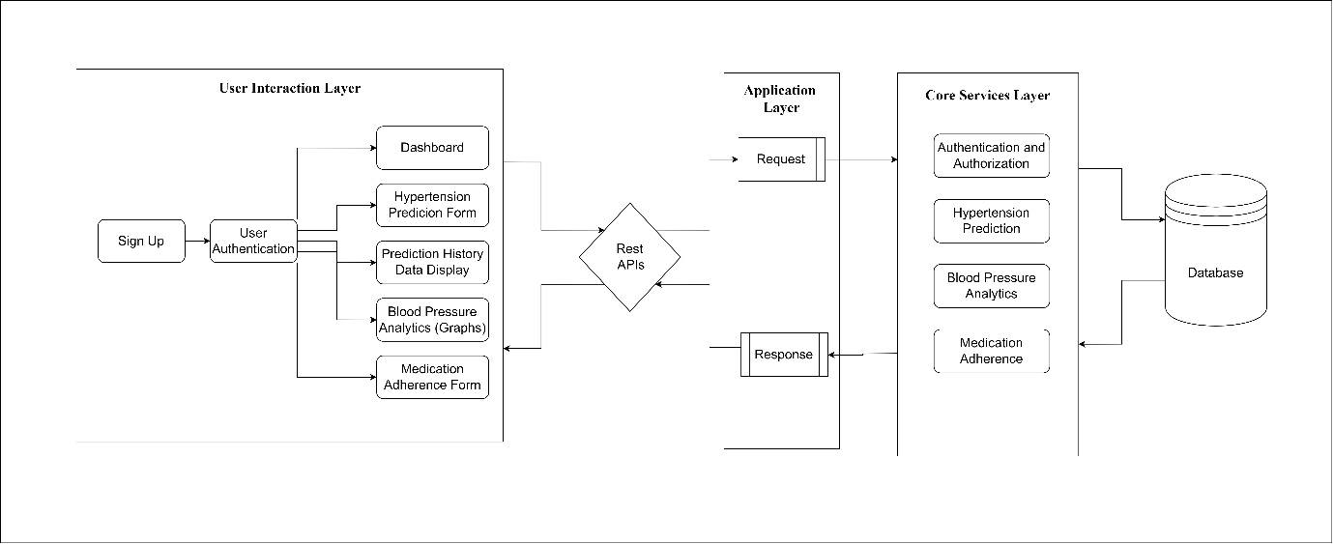

* 1. System Design Models
     1. UML- Activity Diagram

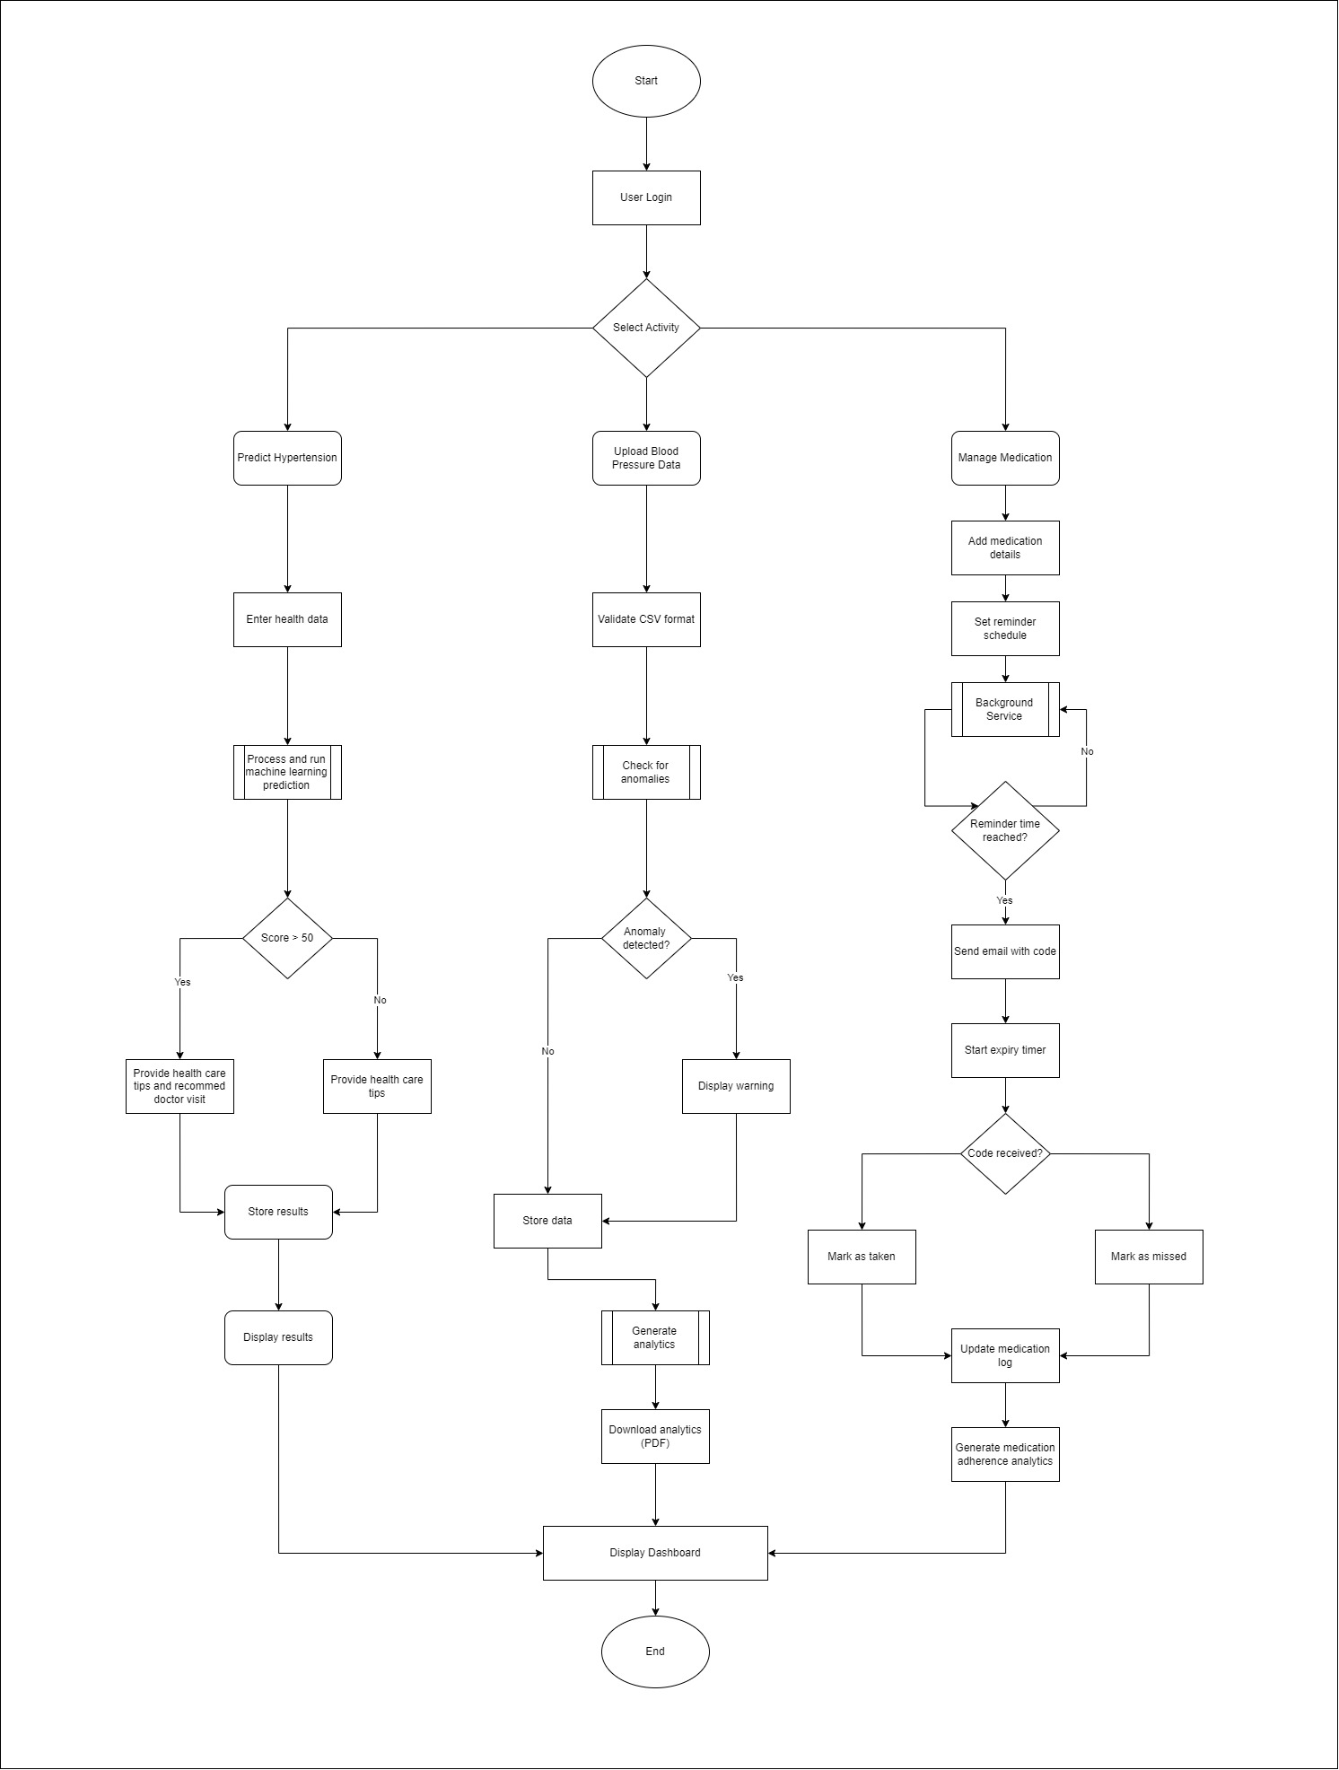

* + 1. UML- Class Diagram
    2. UML- ER Diagram
    3. UML- Sequence Diagram

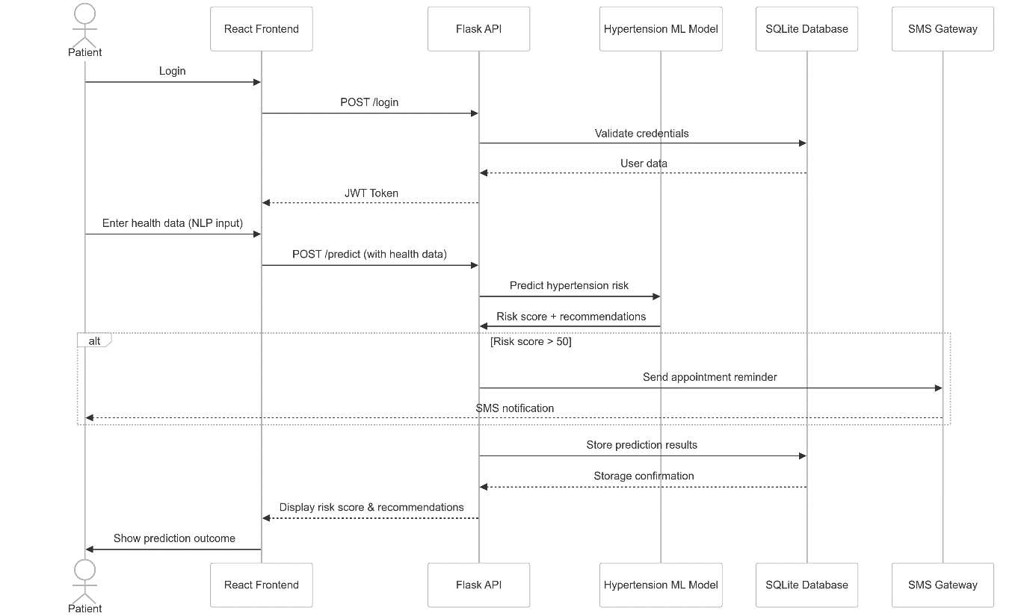

* + 1. UML- Context Diagram
    2. UML- Use case Diagram
  1. Database Modelling
  2. Algorithm Design
  3. Interface Design
  4. Conclusion

**CHAPTER 5: System Testing**

* 1. Introduction
  2. Testing Categories and Results
     1. White Box Testing
     2. Black Box Testing
  3. Types of Testing and Results
     1. Functional Testing
     2. Non-Functional Testing
  4. Test Cases
  5. Levels of Testing and Results
     1. Unit Testing
     2. Integration Testing
     3. Validtion Testing
     4. System Testing
     5. Acceptance Testing
  6. System Evaluation
  7. Conclusion

**CHAPTER 6: Summary, Conclusions and Recommendations**

* 1. Introduction
  2. Limitations of the Project
  3. Scope of Future Work
  4. Recommendations
  5. Summary

**BIBLIOGRAPHY**

**APPENDIX**

**APPENDIX I-** User Manual

**APPENDIX II**- Project Proposal

**APPENDIX III-** Research Paper

NB: Please take note of the following table for the formatting of the document;

|  |  |  |
| --- | --- | --- |
| 1 | Font Size Headings | 14 |
| 2 | General document font size | 12 |
| 3 | Font type | Times New Roman |
| 4 | Font Colour | Black |
| 5 | Line spacing | 1.5 |
| 6 | Document layout | A4 |
| 7 | Paragraph layout | Justified |
| 8 |  |  |

* Please ensure your cover page has no numbering on it.
* Pre-document pages use Roman Numerals
* Rest of document starting from Chapter 1 use numbers, justified to the Right.